Git Hub details:

Url to clone:

<https://github.com/vaishnavi65/FSD.git>

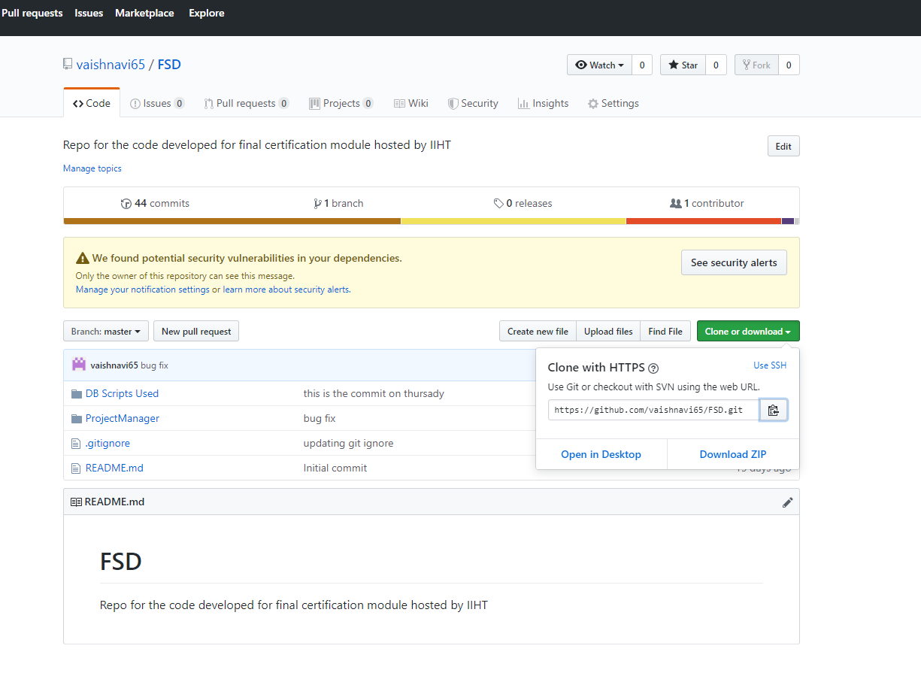

credentials:

vaishnvai65/Sairamsairam123

git folder in VM: C:\Users\Admin\Desktop\FSD\FSD

